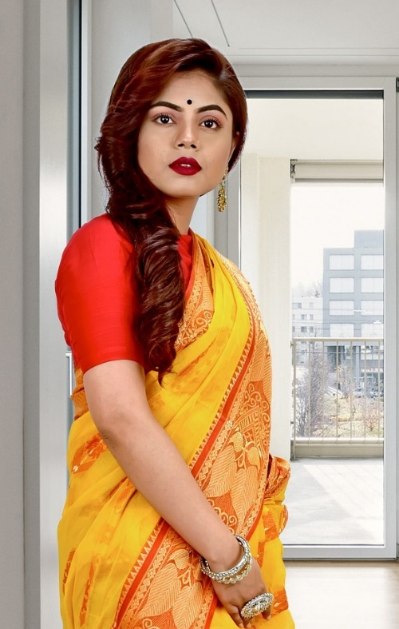

- OVERVIEW

  - Gotra : Shandilya
  - Gan: Devgan
  - Cast: Hinduism
  - Physical Status: Normal
  - Blood Group: “B+ “
  - Language: English, Hindi

- HOROSCOPE
  - Date of Birth: 07/11/2001
  - Birth Time: 11:00 PM
  - Birthplace Hyderabad
  - Mangalik: No
  - Language: Hindi

PUNAM SHOW
07/11/2011 (21 Years old)
- PERSONAL DETAILS
Education: Graduate (B. Com)
Occupation: Accountant
Height: 5ft 6inch
Complex: Fair
Marital status: Never Married

- FAMILY BACKGROUND
Father’s Name: Arjun Show
Mother’s Name: Seema Show
Grand Father’s Name: Sri. Gautam Show
Father’s Occupation: Private Job
Brother: 1. Arun Show, 2. Sunil Show
Sister: Nitu Show
Mama: Ajay Show

- CONTACT DETAILS
Father.: Krishna Show
Mobile No.: 0000000000
WhatsApp.: 0000000000
Address.: 55 R.M. Road, Kolkata, Pin-500000

- EXPECTATIONS FROM PARTNER
I am looking for educated, with minded personality tall and beautiful in the 23 to 25 age group. A realistic approach to life, caring nature, and a willingness to be the torchbearer of family traditions will be a good match.

