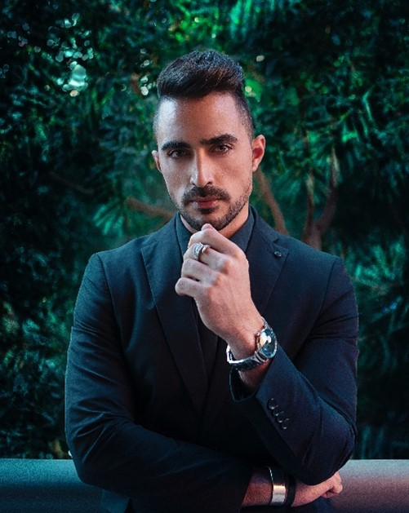
ARYAN BHARADWAJ
AGE: 28 Years
Working as Senior Software Engineer in Wipro.
Date of Birth :- 01/04/1994
Birth Time :- 01:25 PM
Birthplace :- Mumbai
Caste :- Your Cast
Gotra :- Bhardwaj
Gan :- Devgan
Blood Group :- “B” Negative

- PERSONAL DETAILS
Education :- B.Tech in Computer Science
Occupation :- Computer Engineer
Height :- 5ft 11inch
Weight : 79 kgs
Complex :- Fair
Language :- English and Hindi
Marital Status :- Never Married
- FAMILY BACKGROUND
Father’s Name :- Arjun Bhardwaj
Occupation :- Private Job
Mother’s Name :- Seema Bhardwaj
Grand Father’s :- Sri. Gautam BHardwaj
Brother :- Arun Bhardwaj
Sister :- Nitu Bhardwaj
Mama :- Ajay Bhardwaj
- CONTACT DETAILS
Father :- Arjun Bhardwaj, Phone:- 900000000
Address :- 54 Ghat Road, Hyderabad, Pin-777777

- EXPECTATIONS FROM PARTNER
I am looking for educated, with minded personality tall and beautiful in the 24 to 26 age group. A realistic approach to life, caring nature, and a willingness to be the torchbearer of family traditions will be a good match.
- ABOUT MY SELF
I belong to a well-mannered middle class Brahmin family and strongly believe in Hindu Culture, rituals & holds an open-minded personality. I am a pure vegetarian and never drank or smocked. I am Affectionate, Kind-hearted. Caring Happy & believes in hard Working and creativity. My Hobbies are Reading, Dancing watching movies.

