|| श्री गणेशाय नमः ||
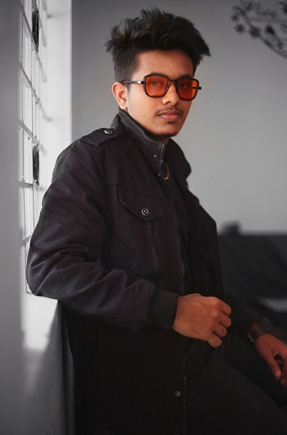
Name : KUNDAN SINGH
Education : B.Tech in Computer Science
Profession : Senior Computer Engineer
Alphat Pvt. Ltd.
Sector-3, Park Circus
Krishna Nagar, Kolkata-777777
office@gmail.com
+91 9999999999
Hobbies : Reading Books
Date of Birth : 01/01/1990 (Age-32)
Birth Time : 01:00 AM
Birthplace : Mumbai
Caste Your : Caste
Gotra : Bhardwaj
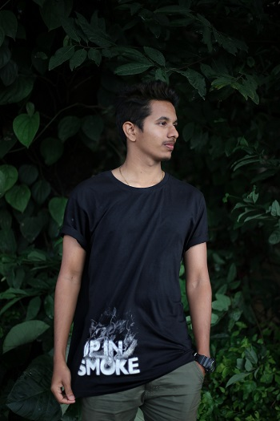
Gan : Devgan
Height : 5ft, 9inch
Complex : Fair
Father’s Name : Arjun Singh
Occupation : Private Job
Mother’s Name: Seema Singh
Grand Father : Sri. Gautam Singh
Brother : Aryan Singh
Sister : Nitu Singh
Residence : JAS Tower
Sector-7, Park Circus
Krishna Nagar, Kolkata-777777
Contact : 9000000000 (Father)
9000000000 (Mother)

EXPECTATIONS FROM PARTNER
I am looking for educated, with minded personality tall and beautiful in the 25 to 26 age group. A realistic approach to life, caring nature, and a willingness to be the torchbearer of family traditions will be a good match.

