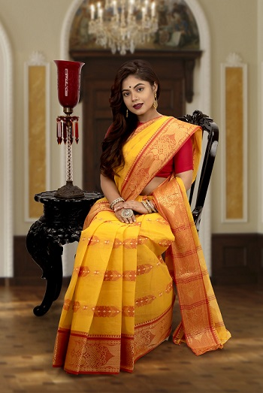
REENA KUMARI
PERSONAL DETAILS

DATE OF BIRTH : 06/01/2000
TIME : 05:00 PM
BIRTHPLACE : PATNA
HIEGHT : 5ft, 5inch
EDUCATION : B.A. (ENGLISH HONS)
OCCUPATION : TEACHER
HOBBIES : READING NEWS PAPER
LANGUAGE : HINDI AND ENGLISH
HOROSCOPE

GOTRA : SHANDILYA
GAN : DEVGAN
CASTE : HINDUISM
FAMILY BACKGROUND

FATHER’S NAME : ARUN MAHATO
MOTHER’S NAME : SEEMA MAHATO
GRAND FATHER : BIKRAM MAHATO
BROTHER : PANAKJ MAHATO (ELDER)
SISTER : NO SISTER
MAMA : SAMIR MAHATO
CONTACT DETAILS

FATHER : ARUN MAHATO
CONTACT NO : 0000000000 (M)
WhatsApp : 0000000000 (M)
ADDRESS : Your Road, Number, District, Area Pin Code

